Modeling an Infectious Disease Epidemic

Outbreaks and epidemics: defined as occurrences of disease beyond expectations for a given time, place and population. Note: pandemic generally refers to geographically widespread epidemic.

How do you define “beyond expectations?” This is one of the uses of surveillance.

Examples: Measles in London
Legionnaire’s disease in Philadelphia
Meningitis on college campuses
Pink eye in a preschool
Bird flu in poultry in Asia

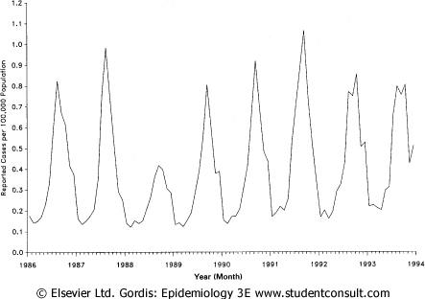
Scientific questions we might want to ask about infectious disease spread and epidemics

Will a given disease become epidemic? How far will it spread?

How many individuals (or what proportion) will become infected?

How long will the disease persist in the population?

Would vaccination prevent an epidemic? If so, what type of vaccination program is most efficient?

What other measures could be taken to prevent an epidemic?

Basic Reproductive Number, R₀

Whether or not an epidemic occurs depends on many factors. A very simple and useful parameter for modeling the potential for an epidemic is the potential for a contagious disease to spread through a population.

We call the average number of individuals directly infected by an infected case during his or her entire infectious period after entering a totally susceptible population the Basic Reproductive Number, R₀.

Activity: Calculate R₀ for the figure. Based on the figure and what you know about real populations, what part of the definition of R₀ is problematic for estimating R₀ like we did?

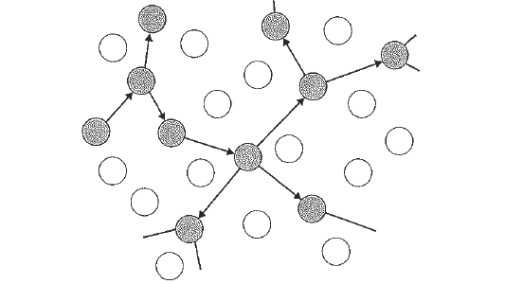

Components of R₀

R₀ = β x κ x D

β is the risk of transmission per contact

κ is the number of such contacts that an average person in the population has per some unit of time

D is the average duration of infectivity for an infected person

Note: κ and D should be measured in the same units of time

Example: A preschool child comes into contact with 20 kids per day on average. If the risk of transmitting pink eye per contact is .80 and duration of disease is 7 days, what is R₀ for pink eye in a preschool?

Each of these components represents a potential route of intervention in the spread of the infection or disease in the population.

R₀ necessary for epidemic to occur

Assume that R₀ = 2, so that each infected person infects 2 other people before they are no longer infected. Also assume that the infections occur in “waves” so that we can keep track of how many people are infected more simply. Consider the following:

1

2

3

4

How many people are infected after each wave?

Wave Number infected

At each wave, more individuals are infected than in the previous wave. What is the formula for determining how many individuals are infected after each wave?

Number affected after wave n =

What if R₀ = 3?

Number affected after wave n =

What value must R₀ be to maintain a constant number of infected individuals in the population?

R₀ =

When the number of infected (sick) individuals in the population is constant over time, we say the infection (disease) is endemic.

What value(s) of R₀ do we require to have the infection eventually disappear from the population?

R₀

Why?

Summary of implications of R₀:

If R₀ < 1 then

If R₀ = 1 then

If R₀ > 1 then

Vaccination level required to prevent epidemic

As you learned in the tutorial, vaccination can provide protection from infection for those who have been successfully vaccinated. What component of R₀ will this affect?

Example: Assume that R₀ = 4 for a disease in the absence of vaccination, with probability of transmission=.40, average number of contacts per day = 5 , and average duration of disease = 2 days. What happens to the probability of transmission, β , (and therefore R₀) if we assume that ¼ of the population has been vaccinated?

Hence, β in the vaccinated population = β in the unvaccinated population –.

In addition, R₀ in the vaccinated population =

Note: R₀ in the vaccinated population = R₀ in the unvaccinated population

What level of vaccination do we require to prevent an epidemic?

We want R₀ in the vaccinated population to be less than 1. Let’s call the unknown proportion of vaccinated individuals V.

We want

If we achieve a level of vaccination that satisfies the above in a given population, we say that the population has achieved herd immunity.

Example continued:

For our above example, R₀ = 4, and so we require V > ?

We would need to vaccinate at least ? of the population to prevent an epidemic for a disease with R₀ = 4.

Other ways to reduce R₀

Note that we can get the same reduction in R₀ by reducing any of the 3 components of R₀ by more than 1 - .

